Synopsis Report
on

EmoScript

Submitted as partial fulfillment for the award of

BACHELOR OF TECHNOLOGY

DEGREE

Session 2021-22
in

Information Technology

By:
Sanidhya Jain (1803213127)
Vanshika Singh (1803213167)
Vanshika (1803213166)
Sanjay Kumar (1803213128)

Under the guidance of:

Ms. Ruchi Jain

(Assistance Professor)

DEPARTMENT OF INFORMATION TECHNOLOGY

ABES ENGINEERING COLLEGE, GHAZIABAD
 |  | 
AFFILIATED TO
DR. A.P.J. ABDUL KALAM TECHNICAL UNIVERSITY, U.P., LUCKNOW
(Formerly UPTU)

Student’s Declaration

We hereby declare that the work being presented in this report entitled “EmoScript” is an authentic record of our own work carried out under the supervision of Ms. Ruchi Jain, Assistant Professor, Information Technology.
The matter embodied in this report has not been submitted by us for the award of any other degree.

Date:22/10/21

Signature of student Signature of student Signature of student Signature of student
(Sanidhya Jain ) (Vanshika Singh ) (Vanshika.) (Sanjay Kumar.)
(1803213127) (1803213167 ) (1803213166) (1803213128)
Department: IT Department: IT Department: IT Department: IT

This is to certify that the above statement made by the candidate(s) is correct to the best of my knowledge.

Signature of HOD Signature of Supervisor
(Name: ) (Name:............................. )

(Name of Department) (Designation)
Date:.......................... (Name of Department)

Acknowledgement

We would like to earnestly acknowledge the sincere efforts and valuable time given by my professor Ms. Rushi Jain. Her valuable guidance and feedback has helped us in completing this project.

Signature of student Signature of student Signature of student Signature of student
(Sanidhya Jain) (Vanshika Singh ) (Vanshika.) (Sanjay Kumar.)
(1803213127) ( 1803213167 ) (1803213166) (1803213128)
Department: IT Department: IT Department: IT Department: IT

Table of Contents

S. No. | Contents | Page No.
 | Student Declaration | 2
 | Acknowledgement | 3
Chapter 1 : | Introduction | 5
Chapter 2 : | Literature Review | 6
Chapter 3 : | Project Objective | 7
Chapter 4 : | Proposed Methodology | 8
Chapter 5 : | Details of Project Work (Design and Implementations) | 9-12
Chapter 6 : | Conclusion and Future Scope | 13
 | References | 14
 | Appendix-I (Coding) | 15-16

Chapter 1 : Introduction
Artificial intelligence (AI) is a wide-ranging branch of computer science concerned with building smart machines capable of performing tasks that typically require human intelligence.
Machine learning and deep learning have been widely embraced, and even more widely misunderstood. In this article, I’d like to step back and explain both machine learning and deep learning in basic terms, discuss some of the most common machine learning algorithms, and explain how those algorithms relate to the other pieces of the puzzle of creating predictive models from historical data.
As new data is fed to these algorithms, they learn and optimize their operations to improve performance, developing 'intelligence' over time. There are four types of machine learning algorithms: supervised, semi-supervised, unsupervised and reinforcement.
Body language in virtual meetings is important to pay attention to because facial expressions, hand gestures and posture can help you communicate and collaborate effectively with colleagues, demonstrate attentiveness and reinforce trust. In our day-to-day lives, our body language and other nonverbal cues emit a host of information to others.
These signals provide key insights about our mood, thoughts, and emotions. In the age of the virtual conference room, nonverbal cues often speak louder than our words.
We intend to create a similar experience in our project. Our project will be based on Artificial Intelligence.

The more the businesses know their customers, the better. To provide the best customer experience, you need to know as much information on your customers as you can. Getting this information is pretty hard if you use traditional methods. However, with the power of Artificial Intelligence, it could be much more effective. Seventy-five percent of companies that have implemented AI and its subdivision, Machine Learning, are boosting customer satisfaction by more than 10%, according to Forbes.

Analysing customer behaviour with the capabilities of AI could save an enormous amount of time, compared to human employees. All the errors that people could make would be eliminated. But that doesn’t mean that data analysts are becoming useless. No, the experts in this scenario will be used for more sophisticated tasks, while machine intelligence will take on routine ones.

Chapter 2: Literature Review
- Predictive Analytics for Predicting Customer Behavior:- Predictive analytics is data utilization, statistical algorithms, and machine-learning techniques to identify possible trends, events, and behaviors in the future based on historical data. This paper tries to propose predictive analytics to predict customer behavior by using behavior informatics and analytics approach so that deeper insight into customer behavior can be obtained to support predictive analysis in order to improve business decision making.
- Customer Segmentation Model Based on Retail Consumer Behavior Analysis:- Customer segmentation is the basis of the customer relationship management (CRM). For the retail business, customer segmentation through certain methods will help the good implementation of customer relationship management.
- Statistics and Analysis of Bank Customers' Financial Consumption Behaviors :- Consumer praxiology is not only the mother of all marketing methods but also the axiom assumption basis of marketing management. Only when the customer's thinking patterns and habits have been learned of can effective marketing means be found and can corporate resources be used creatively.
- An intelligent image-based customer analysis service:- In digital signage application, when customers are viewing ads, the system can automatically analyze multiple attributes of customers, including customer's gender, age, height, viewing distance, the degree of interest and total number of visitors. The advertising companies or store owners can judge potential customers who might interest in some particular products and increase the probability of the products being purchased through those customer analysis data.
- Big data technology and ethics considerations in customer behavior and customer feedback mining:- With the development of Internet of Things and social media network, ethics consideration has also playing an important role in application of big data, especially customer behavior and feedback mining. Our proposed novel system, which extracts the important topics or issues from Skype customer feedback sources and measures the emotion associated with those topics using Vibe metric, can be a good example in this area.
- Improving Customer Relationship Management based on Intelligent Analysis of User Behavior Patterns;- A set of regression, cluster analysis, and association rule mining models, is proposed to search for patterns in user behavior regarding marketing campaigns taking into account user characteristics and financially significant metrics. Using the example of two organizations, it was possible to accurately predict the cost of customer acquisition (CPA, cost-per-action). The use of the models proposed allows organizations to improve advertisement settings to increase online advertising efficiency.
- Customer service experience and satisfaction in retail stores:- The objective of this paper are: (a) to test and validate customer experience quality scale (EXQ) in the Indian retail store context, (b) to see how dimensions of experience quality scale explain customer satisfaction in the Indian retail store context. In this study we have utilised 346 responses on which the analysis was done. Factor analysis and linear multiple regression were used to fulfill the objectives of this study. The result obtained from the multiple regression output reveals that all components of CEQ scale significantly influence customer satisfaction in Indian retail stores context.
- Implementation of Clustering Technique Based RFM Analysis for Customer Behaviour in Online Transactions:- The process of CRM's own business aptitude for integrated information storage, acquisition and decision support is to deliver adapted customer services, which qualifies to analyse customer representatives and classify customer data to sole their needs. This information is very helpful to promote greater customer satisfaction and retention. But nowadays CRM Segmentation models are outdated and deficient because of the excessive and noisy data set.
- Analysis of the behavior of customers in the social networks using data mining techniques:- This paper describes the results of using data mining techniques to analyze the behavior of customers of a fashion company in Instagram social network. The methodology used was CRISP-DM through which the descriptive models using the techniques of clustering and association rules were evaluated. The results shows that the proposed models can provide useful information to designing marketing strategies appropriate according to user preferences.
- Predictive Analytics for Predicting Customer Behavior:- Digital data in large numbers leaves traces of what customers see, what they read, their involvement and behavior, judgment, about their interests and preferences so as to provide a large amount of data that can be mined for learning experiences. The big data value lies in the results of analysis and predictions or actions taken from the results of the analysis and prediction. Predictive analytics is data utilization, statistical algorithms, and machine-learning techniques to identify possible trends, events, and behaviors in the future based on historical data. This paper tries to propose predictive analytics to predict customer behavior by using behavior informatics and analytics approach so that deeper insight into customer behavior can be obtained to support predictive analysis in order to improve business decision making.

Chapter 3 : Project Objective

Our Objective is to create a fully functional website containing features like voice and facial emotion recognition which will widely help business owners to gain more clients and expand their business.

The project will have following objectives:

- To implement behavior and emotion recognition.
- To implement functionalities like uploading image, video and audio to analyze the behavior of a person.
- To integrate our website in a real time meeting to recognize behavior in an ongoing meeting.
- This project will work on two major inputs i.e on facial data of the person and the vocal tone of the person. Based on the type of data provided the module will work on different scales to render the expressions of the customer, as a result it will analyze and detect the mood and behaviour during the meetings.

Chapter 4: Proposed Methodology

The proposed methodology is as follows:

- First, we will work on the front end for the users and implement front end.

- Web pages will include:
- Landing page.
- Page to detect emotion using uploaded image.
- Page to detect emotion using uploaded video.
- Page to detect emotion using uploaded audio.
- Web page to detect emotions during real time meetings.

- Then we will implement backend features like uploading image, audio and video.

- We will implement facial recognition and voice recognition using machine learning algorithms.

- The algorithms that can be used are:

Classical Feature FER Approaches:-
A FER system for recognizing facial expressions requires four steps. First, we need a face detection step that localizes the human face. Representative algorithms include Adaboost [4], Haarcascade [5], and a histogram of oriented gradients (HOG) [6]. The second step involves a face registration with which to obtain the main feature points in order to recognize face rotations or muscle movement. The faces after detection step is inclined to be degraded in terms of recognition accuracy due to the potential for various illuminations and rotations. Therefore, it is necessary to improve the image by obtaining landmarks, which are the positions of the main muscle movements when one is making facial expression.

CNN-Based FER Approaches:-
Recently, due to the development of big data and the improvement of hardware technology, many algorithms based on deep learning have been researched. Since the field of FER is being influenced by these advancements as well, more robust and efficient feature recognition has been achieved through the automatic learning of the extracted facial features. In this section, we introduce the CNN-based FER algorithms.

Chapter 5: Details of Project Work

Classifying images as emotions

Facial Expression Recognition is an Image Classification problem located within the wider field of Computer Vision. Image Classification problems are ones in which images must be algorithmically assigned a label from a discrete set of categories. In FER systems specifically, the images are of human faces and the categories are a set of emotions.

Machine learning approaches to FER all require a set of training image examples, each labeled with a single emotion category. A standard set of seven emotion classifications are often used:

- Anger
- Disgust
- Fear
- Happiness
- Sadness
- Surprise
- Neutral

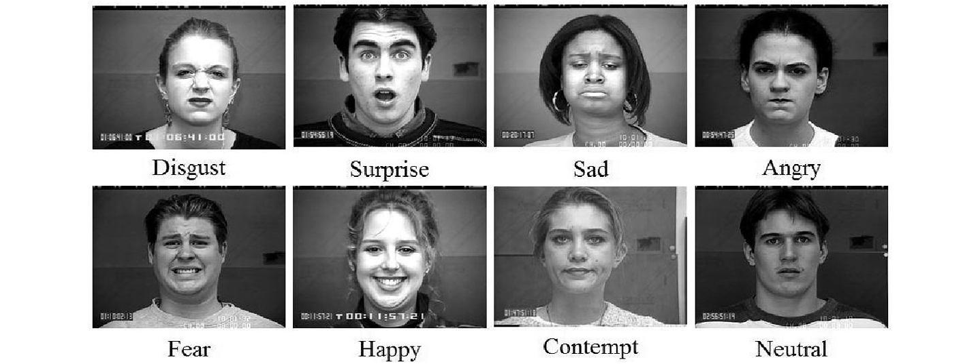

Flow of the Process:-
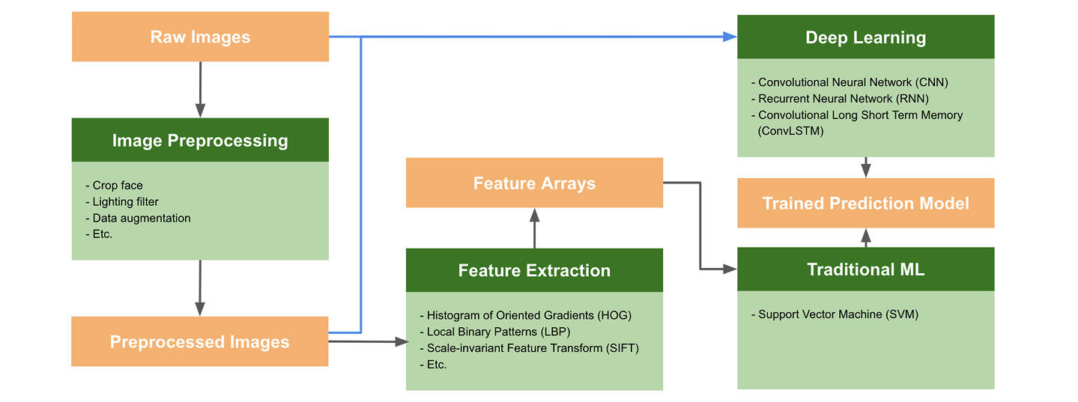

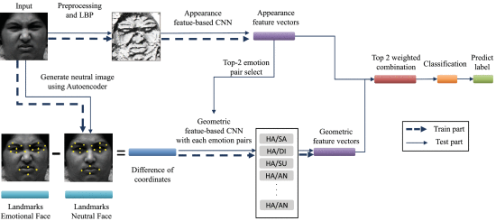

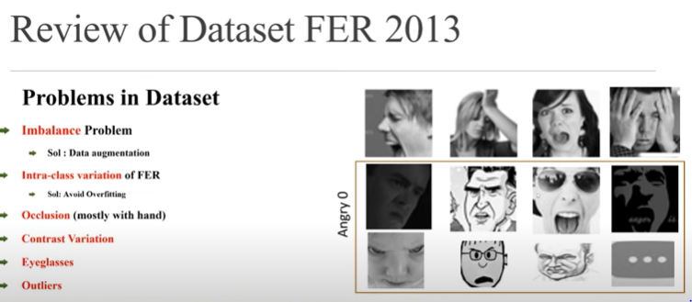
Implementations:-
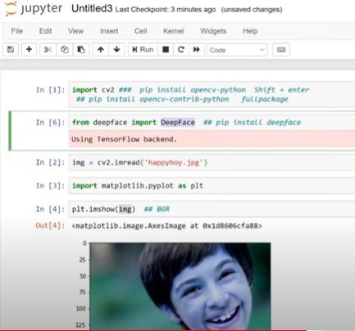

UML Diagrams:-
Sequence Diagram:-
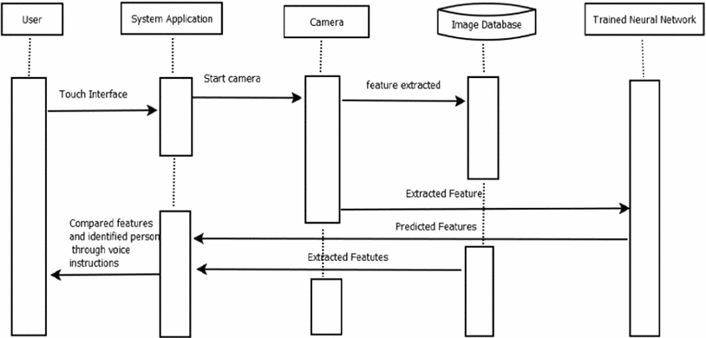

Chapter 6: Conclusion And Future Scope

Conclusion:
- The emerging growth and development in the field of technology have led to the new era of AI and Machine Learning.
- Speech and facial recognition is one of the widely used application of ML.
- The project model has the capability to become one of the most widely used models in business industry.

Future Plan:
- For future advancements, the proposed project can be further modeled in terms of efficiency, accuracy, and usability. Additional to the emotions, the model can be extended to recognize feelings such as depression.
- The project can be converted into a mobile application.
- The project model can also be used in other fields in future, like in E-commerce- It can help sellers sell their products by recognizing the reaction of buyer towards the product

REFERENCES :

- G. Eason, B. Noble, and I. N. Sneddon, “On certain integrals of Lipschitz-Hankel type involving products of Bessel functions,” Phil. Trans. Roy. Soc. London, vol. A247, pp. 529–551, April 1955. (Journal Paper)
- S. r. Ayyubi, Y. Miao, and H. Shi, "Automating standalone smoke alarms for early remote notifications," in 13th Intern. Conf. on Cont. Automa. Robotics & Vision (ICARCV), Marina Bay Sands Singapore, Dec. 2014, pp. 675–680. (Conf Paper)
- I. S. Jacobs and C. P. Bean, “Fine particles, thin films and exchange anisotropy,” in Magnetism, vol. III, G. T. Rado and H. Suhl, Eds. New York: Academic, 1963, pp. 271–350. (Journal)
- J. Clerk Maxwell, A Treatise on Electricity and Magnetism, 3rd ed., vol. 2. Oxford: Clarendon, 1892, pp.68–73. (Book)
- M. Crawford, Catching the Sun, American Society of Mechanical Engineers, Feb. 2013. Accessed on: Oct 12, 2020. [Online]. Available: https://www.asme.org/engineering-topics/articles/renewable-energy/catching-the-sun. (Online Content with Author)
- “Engineering Triumph That Forged a Nation: Panama Canal Turns 100,” Aug. 15, 2014. Accessed on: Oct. 12, 2020. [Online]. Available: http://www. msnbc.msn.com/news/world/engineering-triumph-forged-nation-panama-canal-turns-100-n181211 (Online Content without author)

Appendix 1(Coding):-
# We install the FER() library to perform facial recognition
# This installation will also take care of any of the above dependencies if they are missing
In [2]:
pip install fer
from fer import FER
import matplotlib.pyplot as plt
%matplotlib inline

test_image_one = plt.imread("/content/Image-One.jpeg")
emo_detector = FER(mtcnn=True)
# Capture all the emotions on the image
captured_emotions = emo_detector.detect_emotions(test_image_one)
# Print all captured emotions with the image
print(captured_emotions)
plt.imshow(test_image_one)

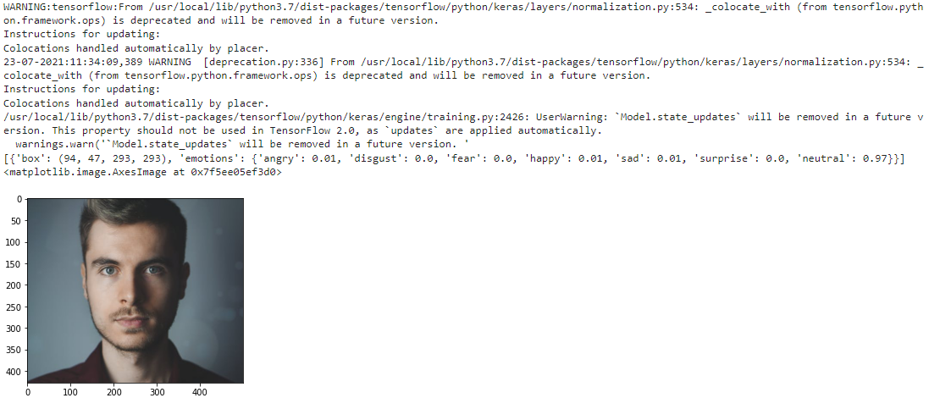

# Use the top Emotion() function to call for the dominant emotion in the image
dominant_emotion, emotion_score = emo_detector.top_emotion(test_image_one)
print(dominant_emotion, emotion_score)

# We repeat the same steps for a few other images to confirm the performance of FER()
test_image_two = plt.imread("/content/Image-Two.jpg")
captured_emotions_two = emo_detector.detect_emotions(test_image_two)
print(captured_emotions_two)
plt.imshow(test_image_two)
dominant_emotion_two, emotion_score_two = emo_detector.top_emotion(test_image_two)
print(dominant_emotion_two, emotion_score_two)
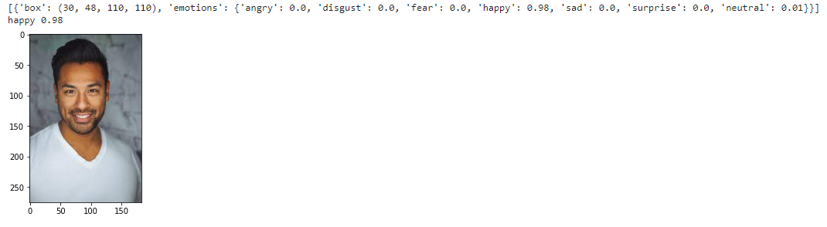
# Testing on another image
test_image_three = plt.imread("Image-Three.jpg")
captured_emotions_three = emo_detector.detect_emotions(test_image_three)
print(captured_emotions_three)
plt.imshow(test_image_three)
dominant_emotion_three, emotion_score_three = emo_detector.top_emotion(test_image_three)
print(dominant_emotion_three, emotion_score_three)

